Introduction to linear programming
Question 1:
What is the primary goal of optimisation?
- To complicate a process
- To make something the best it can be
- To find an average solution
- To ignore constraints
Answer: b

Question 2:
Which of the following is NOT a component of an optimisation problem?
- Decision Variables
- Objective function
- Constraints
- Random numbers
Answer: d

Question 3:
In linear programming, the objective function is:
- Quadratic
- Linear
- Exponential
- Logarithmic
Answer: b

Question 4:
What does a feasible solution in linear programming NOT do?
- Satisfy all constraints
- Violate any constraints
- Result in an optimal value
- Represent a possible decision
Answer: b

Question 5:
Which of the following is a potential special case in linear programming?
- Multiple optimal solutions
- Single optimal solution
- Quadratic solution
- Exponential solution
Answer: a

Question 6:
A company is assigning 5 employees to 5 different tasks. The cost of assigning each employee each task varies. The goal is to minimize the total cost. This problem can be solved using:
- Linear Regression
- Goal programming
- Assignment Problem techniques
- Maximal flow analysis
Answer: c

Question 7:
In regression analysis, if you add more independent variables to your model and the R-squared value increases, but the adjusted R-squared value does not significantly increase, this suggests?
- The added variables are significant predictors
- The added variables may not add much explanatory power
- Multicollinearity is not present
- The model is perfect.
Answer: b

Question 8:
In simple linear regression, a negative slope indicates:
- The dependent variables increase as the independent variable increases.
- The dependent variable decreases as the independent variable increases.
- There is no relationship between the variables.
- The y-intercept must be negative.
Answer: b

Question 9:
You have a linear programming problem where the feasible region is bounded. The optimal solution will always occur:
- At the origin (0,0)
- At any point within the feasible region
- At a corner point of the feasible region
- Where the objective function
Answer: c

Question 10:
Which of the following is a characteristic of goal programming?
- It seeks to optimize a single objective.
- It always finds a feasible solution.
- It minimizes deviations from multiple goals.
- It uses only hard constraints.
Answer: c

Question 11:
A small bakery makes cakes and cookies. A cake requires 2 hours of labour and 3 lbs of flour, while a batch of cookies requires 1 hour of labour and 1 lb of flour. The bakery has 40 hours of labor and 4 lbs of flour available. If cakes sell for $15 and cookies sell for $8, what should be the objective function and constraints to maximize revenue using Excel Solver?
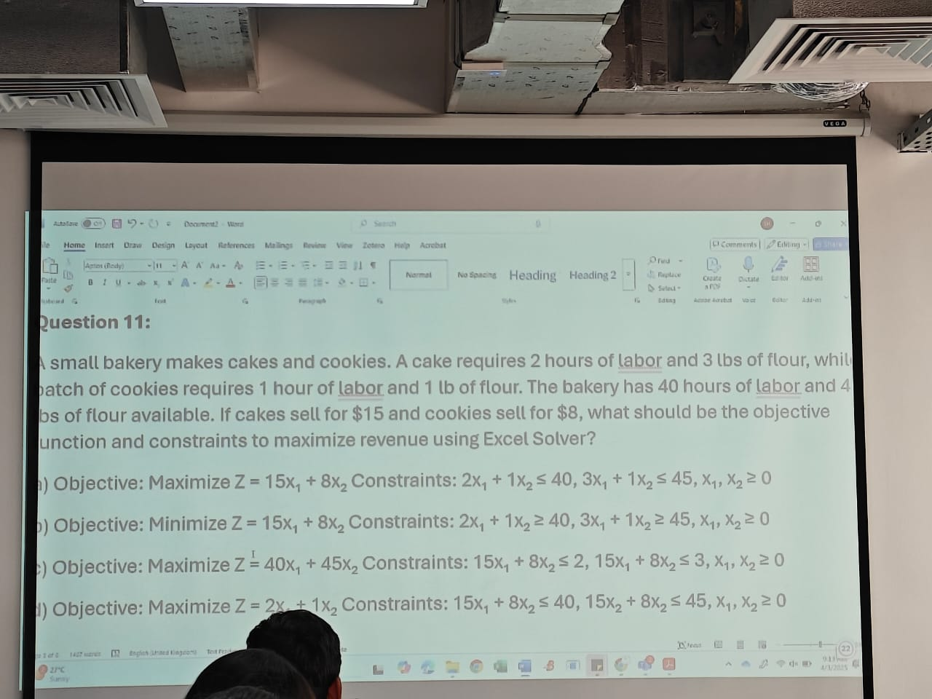
Answer: a

Question 12:
A company wants to blend two types of juice to create a blend with at least 50% orange juice and 20% grapefruit juice. Juice A is 60% orange juice and 10% grapefruit juice and costs $1.00 per liter. Juice B is 40% orange juice and 30% grapefruit juice and costs $0.80 per liter.
If you set up this problem in Excel Solver to minimize cost, what would the constraint for the minimum percentage of orange juice be (where X1 = liters of Juice, X2 = liters of Juice B)?
- 0.6X1 + 0.4X2 >= 0.5
- 0.6X1 + 0.4X2 <= 0.5 (X1 + X2)
- 0.6X1 + 0.4X2 >= 0.5 (X1 + X2)
- 0.1X1 + 0.3X2 >= 0.2 (X1 + X2)
Answer: c

Question 13:
A factory produces chairs and tables. A chair requires 1 hour of assembly and 3 hours of finishing. A table requires 2 hours of assembly and 2 hours of finishing. There are 120 hours available for assembly and 180 hours available for finishing. The profit per chair is $40 and per table is $50.
If you use Excel Solver to find the optimal production mix, which cell in your Excel sheet represents the total profit? Assume the number of chairs is in cell A1 and the number of tables in cell B1.
- =A1+B1
- =MAX(A1*40, B1*50)
- =SUM(A1*40, B1*50)
- =A1*50 + B1*40
Answer: c

Question 14:
A transportation problem involves shipping goods from 3 sources to 4 destinations. In an Excel Solver model for this problem:
- The objective function would minimize total shipping cost.
- The constraints would ensure that the supply at each source is met.
- The constraints would ensure that demand at each destination is exceeded.
- The decision variables would represent the unit shipping cost.
Answer: a b,c partially correct
Question 15:
A company is deciding how much of two products, X and Y, to produce. Product X has a profit of $10 per unit, and product Y has a profit of $12 per unit. It takes 2 hours to produce one unit of X and 1 hour to produce one unit of Y. There are 100 hours of production time available.
If ‘X’ represents the number of units of product X and ‘y’ represents the number of units of product Y, which Excel Solver setup correctly models this problem to maximize profit?
- Objective function: = 10*x + 12*y, Changing Cells: x,y, Constraints: 2*x+1*y <= 100
- Objective function: = x + y, Changing Cells: x,y, Constraints: 10*x+12*y <= 100
- Objective function: = 2*x + 1*y, Changing Cells: x,y, Constraints: 10*x+12*y <= 100
- Objective function: = 10*x + 12*y, Changing Cells: x,y, Constraints: x+y <= 100
Answer: a

Integer Programming
Question 16:
A company is considering opening warehouses in 4 cities. Let X1, X2, X3, and X4 be binary variables representing whether to open a warehouse in city 1, 2, 3, and 4, respectively (1 = open, 0 = don’t open). The constraints X1 + X2 + X3 + X4 = 2 means:
- Exactly two warehouses must be opened.
- No more than two warehouses can be opened.
- At least two warehouses must be opened.
- If a warehouse is opened in city 1, one must also be opened in city 2.
Answer: a

Logical constraints come for the ICT

Question 17:
In an integer programming problem solved with Solver, If a decision variable represents the number of machines to purchase, the constraint type for that variable should be set to:
- Continous
- Integer
- Binary
- All different
Answer: b

Question 18:
A project has 5 tasks. Task A must be completed before B and C can start. Tasks C and D must be completed before E can start. If we use integer programming to model whether or not to do each task (1 = do the task, 0 = don’t ), which constraint correctly represents that Task A must be done before Task B? (where A, B, C, D, and E are the binary variables for each task)
- B <= A
- A <= B
- A + B = 1
- A - B = 0
Answer: a

Question 19:
In a shortest-path problem solved using Excel Solver, the objective is typically to:
- Maximize the flow through the network.
- Minimize the total distance or cost.
- Maximize the number of nodes visited.
- Find all possible paths.
Answer: b

Question 20: (transhipment)
In the maximal flow problem, what does the sum of the flow into a node equal?
- The capacity of the arcs leaving the node.
- The flow out of the source node.
- The flow into the sink node.
- The sum of the flow out of that node.
Answer: d

Question 21:
In Excel, you can use regression to find the line of best fit. If you have sales data (y) and advertising spending (x), and Solver calculates the equation y=500 + 10x, what does the ‘10’ represent?
- The total sales
- The fixed sales when advertising is 0
- The increase in sales for each dollar spent on advertising
- The cost of advertising
Answer: c

Question 22:
When using Excel Solver for multiple regression, what does the standard error of a coefficient indicate?
- The overall fit of the model
- The predicted value of the dependent variable
- The reliability of that coefficient as a predictor
- The correlation between independent variables
Answer: c

ICT MOCK ANSWER
Question 1:
Answer: decrease 3000 unit

Question 2:
Y = 7 + 2X1 + 9X2 question
Answer:

Question 3:
Excel sheet p3.xlsx
Answer: The model with one independent variable, i.e., admission

If simple regression, look at R-squared
If multiple regression, look at adjusted R-squared

Question 4:
Considering a linear programming problem:
Max 3x1 + 4x2
S.t. 4x1 + 3x2 >= 12
-2x1 -3x2 <= 6
Answer: exhibits unboundedness

Question 8
Assign problem (worker, job problem)
Answer: 16

Question 10
Profit of goal number 1, 3600 and profit 3300 question
Answer: 300

